**ELECTRICAL ENGINEERING**

**YEAR 3**

**ISHIMWE Louis Honore 19RP05638**

**BIZERWA Myfriend 19RP03470**

**TOPIC: TURNING ON A BULB LAMP USING PIR SENSOR AND GIVE NOTIFICATION THROUGH GSM**

**1. ABSTRACT**

Home safety systems are necessary characteristic of present day residential and workplace installations. Home security systems will be accessible, dependable and functional. So here there is project based on the Security system using PIR Sensor, Arduino Uno, and GSM module “SIM900A”. The PIR sensor is used for Intruder detection. Whenever an unauthorized person is detected a message is sent on the desired number. A relay module is also connected with the Arduino Uno which can be used to turn on a light as an indication that intruder is detected. This project can be used in other many fields where we need to be secured and to keep our properties safe like institutions, warehouses, homes, ….

**2. PROBLEM STATEMENT**

The PIR sensor is responsible for detecting the change in infrared radiation levels when an intruder or human is passed through the system or space where it is arranged. Depending on the change in radiation levels the change in voltages occurs and then with this voltage the signal is amplified and hence the light is produced with a bulb. Thus it is helpful in various applications and areas. In this paper passive Infrared sensor “PIR” based security system is introduced. With this sensor we can save power, switch the bulbs automatically and effective management at low cost and requires small memory space.

**3. BLOCK DIAGRAM**

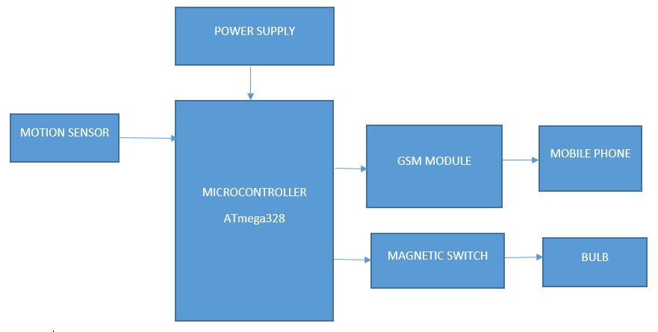

**4. CIRCUIT DIAGRAM DRAWN IN FRITZING**

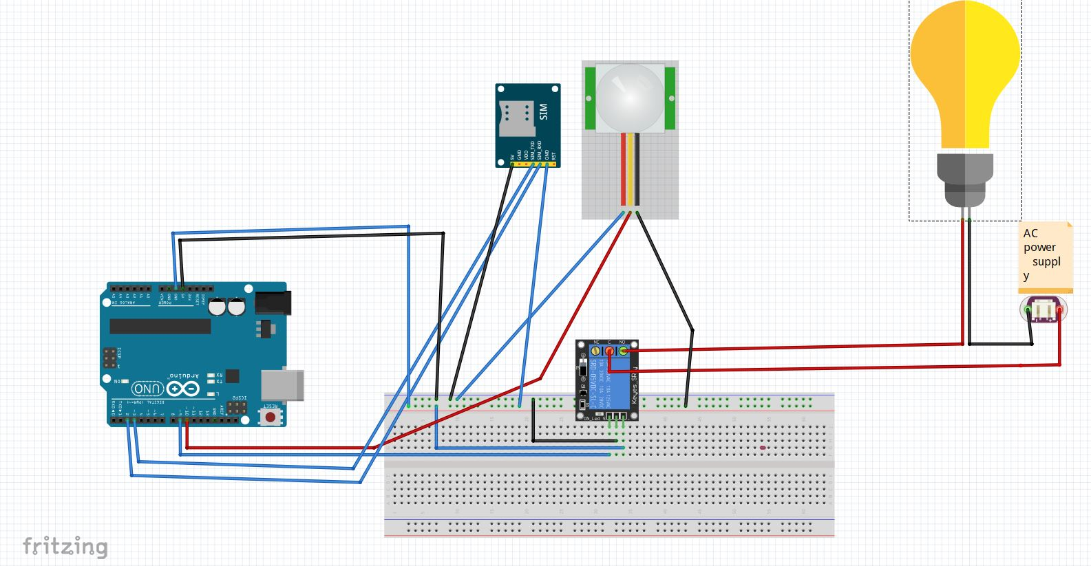

**5.SIMULATION IN PROTEUS**

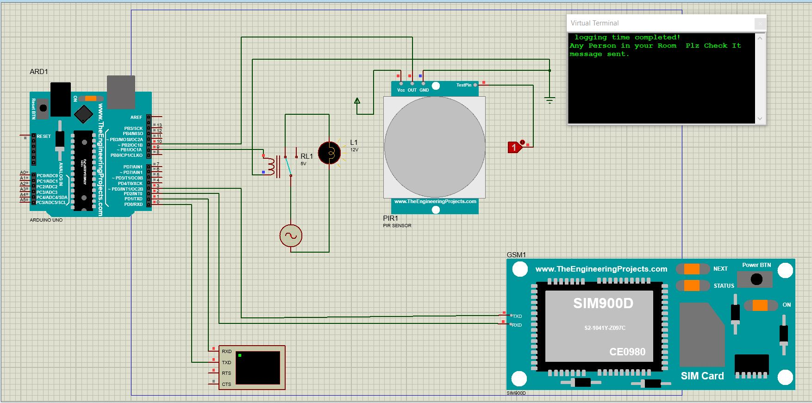

**5.ARDUINO SOURCE CODES**

#include <SoftwareSerial.h>

SoftwareSerial SIM900(2, 3);

String textForSMS;

int pirsensor = 10;

int led= 9;

void setup() {

randomSeed(analogRead(0));

Serial.begin(9600);

SIM900.begin(9600);

Serial.println(" logging time completed!");

pinMode(pirsensor, INPUT);

pinMode(led, OUTPUT);

digitalWrite(led, LOW);

delay(100);

}

void loop() {

if ( digitalRead(pirsensor) == HIGH) //

{

textForSMS = "\Any Person in your Room Plz Check It ";

digitalWrite(led, HIGH);

sendSMS(textForSMS);

Serial.println(textForSMS);

Serial.println("message sent.");

delay(8000);

}

if ( digitalRead(pirsensor) == LOW) //

{

digitalWrite(led, LOW);

delay(1000);

}

}

void sendSMS(String message)

{

SIM900.print("AT+CMGF=1\r");

delay(1000);

SIM900.println("AT + CMGS = \"+250781668997\"");

delay(1000);

SIM900.println(message);

SIM900.println((char)26);

delay(1000);

SIM900.println();}